You are given a doubly linked list which in addition to the next and previous pointers, it could have a child pointer, which may or may not point to a separate doubly linked list. These child lists may have one or more children of their own, and so on, to produce a multilevel data structure, as shown in the example below.

Flatten the list so that all the nodes appear in a single-level, doubly linked list. You are given the head of the first level of the list.

**Example 1:**

**Input:** head = [1,2,3,4,5,6,null,null,null,7,8,9,10,null,null,11,12]

**Output:** [1,2,3,7,8,11,12,9,10,4,5,6]

**Explanation:**

The multilevel linked list in the input is as follows:

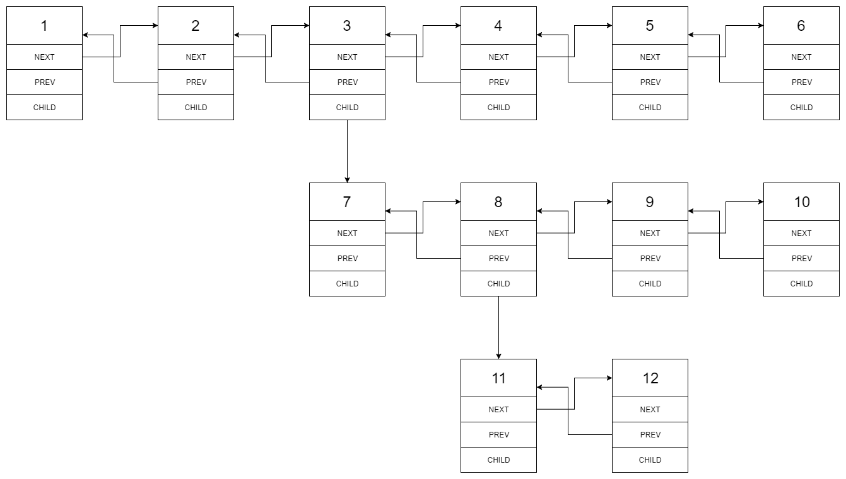

After flattening the multilevel linked list it becomes:



**Example 2:**

**Input:** head = [1,2,null,3]

**Output:** [1,3,2]

**Explanation:**

The input multilevel linked list is as follows:

1---2---NULL

|

3---NULL

**Example 3:**

**Input:** head = []

**Output:** []

**How multilevel linked list is represented in test case:**

We use the multilevel linked list from **Example 1** above:

1---2---3---4---5---6--NULL

|

7---8---9---10--NULL

|

11--12--NULL

The serialization of each level is as follows:

[1,2,3,4,5,6,null]

[7,8,9,10,null]

[11,12,null]

To serialize all levels together we will add nulls in each level to signify no node connects to the upper node of the previous level. The serialization becomes:

[1,2,3,4,5,6,null]

[null,null,7,8,9,10,null]

[null,11,12,null]

Merging the serialization of each level and removing trailing nulls we obtain:

[1,2,3,4,5,6,null,null,null,7,8,9,10,null,null,11,12]

**Constraints:**

* Number of Nodes will not exceed 1000.
* 1 <= Node.val <= 10^5